**Greater Bethel Missionary Baptist Church**

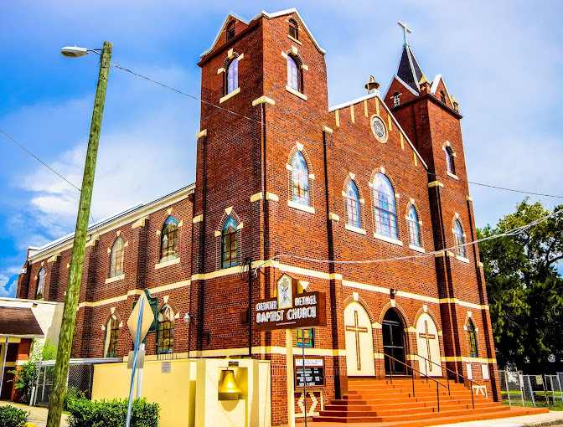

**GREATER BETHEL MISSIONARY BAPTIST CHURCH**

**131 YEAR ANNIVERSARY**

**COMMUNITY FALL FESTIVAL**

**OCTOBER 12, 2024**

**Perry Harvey Sr. Park**

**1000 E. Harrison St. Tampa, FL. 33602**

**10:00AM – 5:00PM**

**NO VENDOR FEE YOU KEEP ALL PROCEEDS**

**MARK ADAMS**

**813-377-9888**

**131 Anniversary**

**Tddd**